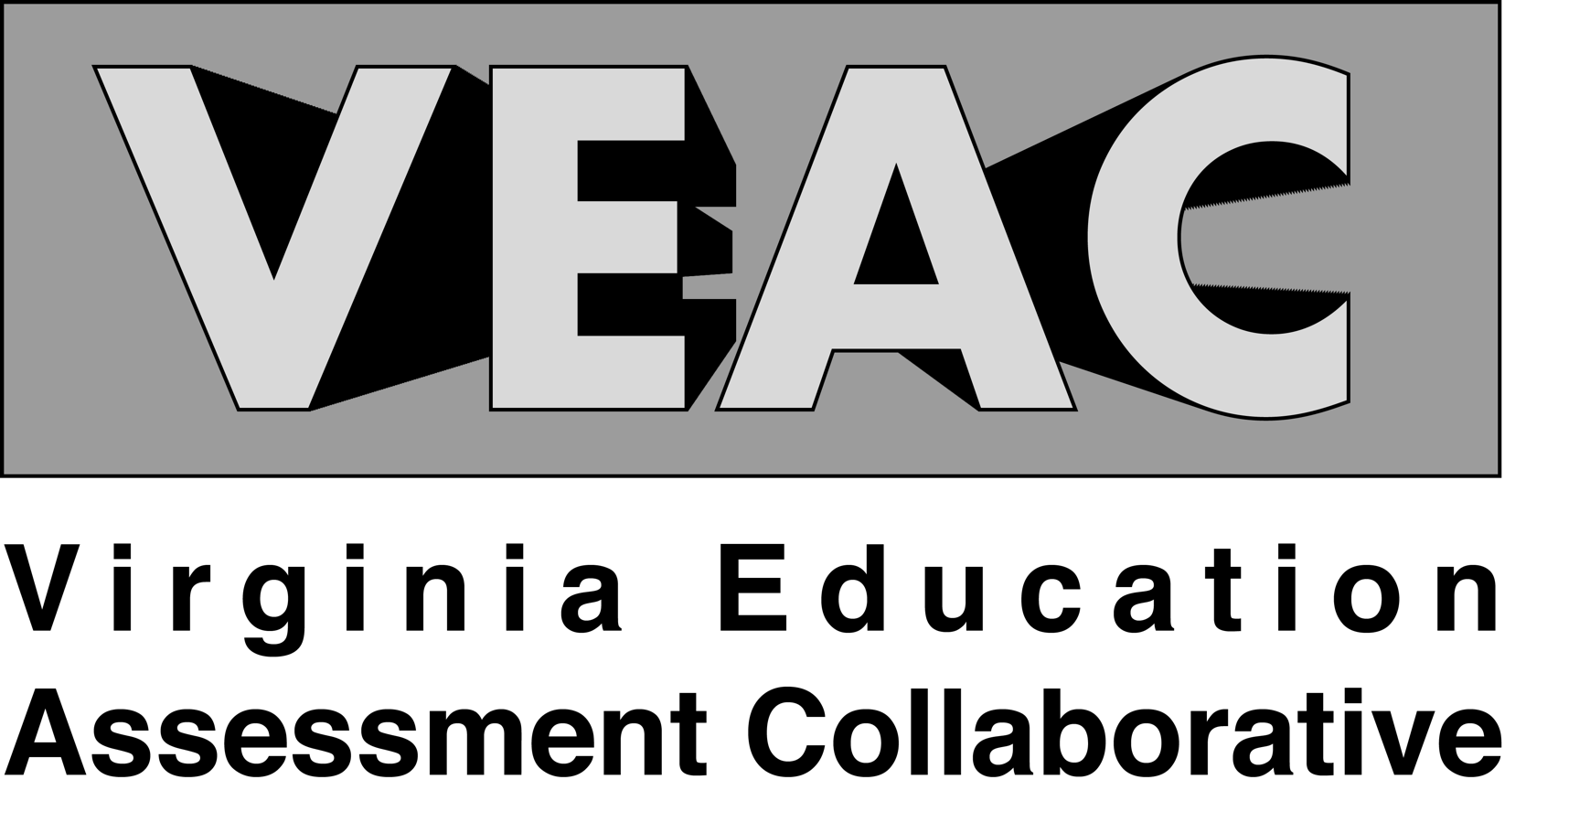

University of Virginia

Initial Licensure Employer Survey

2021-2022 Cycle

Virginia Education Assessment Collaborative

The Virginia Education Assessment Collaborative (VEAC) is a growing partnership between Educator Preparation Programs (EPP) in the Commonwealth of Virginia. Our purpose is to provide a centralized assessment structure for Virginia EPPs that standardizes and reduces the complexity of data collection for both the Virginia Department of Education (VDOE) and the Council for the Accreditation of Educator Preparation (CAEP).

2021-22 VEAC Leadership

Chairs
Amy Thelk – James Madison University
Mandy Turner - University of Virginia
Joel Hanel – University of Virginia

Executive Director
Jillian McGraw – University of Virginia

Communications
Adrienne Sullivan – George Mason University

Committee Leadership
Maggie Barber – Old Dominion University
Matt Grimes – Radford University
Angie Wetzel – Virginia Commonwealth University

Graduate Student
Anne McAlister – University of Virginia
Kaela Henon – Radford University

Data Collection Process

VEAC partners submitted contact information for program completers and employer to VEAC in January 2022. Initial recruitment for the survey began on April 12, 2022 and was open with reminders through August 23, 2022.

Survey Response Rates

For our 2021-2022 initial licensure cycle, VEAC fielded the Employer Survey to program completers from 29 EPP partners.

Upon closing the survey in August 2022, VEAC collected 1,169 complete and partial responses resulting in an 29% response rate.

For University of Virginia, the EPP had a 25% response rate on the VEAC Employer Survey based on the total number of contacts submitted to VEAC minus the number of failed/bounced emails.

VEAC provides EPP partners access to a responsive dashboard to view holistic data from the 2021-2022 VEAC cycle. Further, the dashboard supports benchmark reference points through interactive data disaggregation by relevant EPP characteristics (e.g., EPP Size, EPP Type (public/private), Endorsement Level, etc.). Access the VEAC completer survey dashboard at www.projectveac.org.

EPPs can find responses to the two open ended response items in their shared Box folder.

Survey Response Data

Table 1 provides responses to the 2021-22 VEAC Initial Licensure Survey. Column 1 (VEAC Item) provides the text for each VEAC survey item. Column 2 (N) provides the total number of responses to the survey from all VEAC partners minus the number of NA responses. Column 3 (VEAC) provides the average response to the item for all responses from all VEAC partners along with the standard deviation in parenthesis. Column 4 (EPP) provides the average response to the item by the specific EPP along with the specific EPP standard deviation in parenthesis. Column 5 (p-value) provides the p-value from a two-tail difference in means test between the VEAC mean (column 3) and the institution specific mean (column 4). The second row for each item provides the count of NA responses. Item wording and coding are found in Appendix A.

Table 1: University of Virginia 2021-22 Report
VEAC Item | VEAC N | VEAC Mean, (SD) | EPP N | EPP Mean, (SD) | p-value
A: Demonstrates an understanding of the curriculum, subject content, and the developmental needs of students by providing relevant learning experiences. * | 1,105 | 3.37, (0.87) | 73 | 3.55, (0.50) | 0.001
B: Plans using state standards, the school’s curriculum, effective strategies, resources, and data to meet the needs of all students. * | 1,105 | 3.36, (0.91) | 73 | 3.55, (0.50) | <0.001
C: Effectively engages students in learning by using a variety of instructional strategies in order to meet individual learning needs. * | 1,105 | 3.35, (0.93) | 73 | 3.45, (0.62) | 0.053
D: Systematically gathers, analyzes, and uses all relevant data to measure student academic progress, guide instructional content and delivery methods, and provide timely feedback to both students and parents throughout the school year. * | 1,105 | 3.31, (1.10) | 73 | 3.44, (0.62) | 0.002
E: Uses resources, routines, and procedures to provide a respectful, positive, safe, student-centered environment that is conducive to learning. * | 1,105 | 3.37, (0.95) | 73 | 3.48, (0.60) | 0.045
F: Maintains a commitment to professional ethics, communicates effectively, and takes responsibility for and participates in professional growth that results in enhanced student learning. * | 1,105 | 3.43, (0.92) | 73 | 3.56, (0.55) | 0.019
G: Work results in acceptable, measurable, and appropriate student academic progress* | 1,105 | 3.33, (0.97) | 73 | 3.41, (0.57) | 0.038
H: Selects technologies, informed by research, to promote learning for all students. * | 1,105 | 3.42, (1.12) | 73 | 3.44, (0.55) | 0.046

Table 1: University of Virginia 2021-22 Report Cont.
VEAC Item | VEAC N | VEAC Mean, (SD) | EPP N | EPP Mean, (SD) | p-value
I: Integrates technology into instructional materials. * | 1,105 | 3.45, (1.03) | 73 | 3.49, (0.56) | 0.028
J: Brings multiple perspectives to instruction, including the learners' personal, family, and community experiences / norms. * | 1,105 | 3.40, (1.15) | 73 | 3.48, (0.60) | 0.007
K: Integrates diverse language and cultures into instruction to promote the value of multilingual / multicultural perspectives. * | 1,105 | 3.54, (1.53) | 73 | 3.38, (0.64) | 0.075
L: Collaborates with the learning community to meet the needs of all learners and contribute to a supportive culture. * | 1,105 | 3.38, (0.93) | 73 | 3.45, (0.62) | 0.072
M: Uses assessment results to inform and adjust practice. * | 1,105 | 3.34, (1.08) | 73 | 3.47, (0.60) | 0.002
N: Engages in reflective practice. * | 1,105 | 3.41, (1.10) | 73 | 3.58, (0.85) | 0.015
Based on your experience with this teacher, what best describes the extent to which they were ready to meet the needs of students in your school? ** | 1,100 | 4.43, (0.79) | 73 | 4.66, (0.56) | 0.016
* Items Range from 1-4
** Item Ranges from 1-5

Appendix A: Survey Item Wording and Coding Description

InTASC Satisfaction Items
Items A through N ask program completers’ employers to rate their performance on 14 VUPS/InTASC items. Specifically, these items ask, “Please rate [Field-C.FirstName] [Field-C.LastName]'s performance on each of the following.” Respondent can choose “Exemplary,” “Proficient,” “Developing/Needs Improvement,” or “Unacceptable.” To find the average rating, responses are coded, from 1 to 4. Higher values indicate more proficiency, and lower values indicate more unacceptability. Items with an * in Table 1 are the InTASC Satisfaction Items.

Overall Satisfaction Item
The last item in the VEAC employer survey that asks “Based on your experience with this teacher, what best describes the extent to which they were ready to meet the needs of students in your school?” Respondent employers could respond “Fully ready (able to have an immediate impact on student learning), Mostly ready (able to successfully meet the needs of most students,” “Moderately ready (in order to be successful, needed additional training, support, and coaching beyond what is typically provided to beginning teachers),” “Minimally ready (limited success meeting the needs of students and improving outcomes even with additional supports)” or “Not ready (unable to meet the needs of students even with additional supports).” Higher values indicate more satisfaction, and lower values indicate more dissatisfaction. The Item with a ** in Table 1 is the Overall Satisfaction Item.

